Chapter 10, Problem 10.

Use nodal analysis to find v_{o} in the circuit shown in Fig. 10.59. Let ω = 2 krad/s.

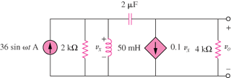

Figure 10.59
For Prob. 10.10.

